**PJ 7 Report Your Name: Francisco Valadez**

**A. The following is my Java program:**

**// Please copy your Java program into here from your Eclipse window. The code must be colored.**

**// You must not copy Java program from your .java file since the code over there is not colored at all.**

**// You must not show screen prints here.**

// Author: Francisco Valadez  
// Date: 5/28/2021  
// Purpose: This program is a array based stack and queue game!  
  
import java.util.Scanner;  
  
public class Queue_Game  
{  
 public static String[] stackArray = new String[30];  
 public static String[] queueArray = new String[30];  
 public static int linecounter = 1;  
   
 //this function removes elements from the queue array  
 public static void pop()  
 {  
 int counter = 0;  
 for(int i = 0; i < stackArray.length; ++i)  
 {  
 if(stackArray[i] == null)  
 ++counter;  
 }  
  
 //checks if queue is empty and if not then removes the elements  
 if(counter == stackArray.length)  
 {  
 System.out.println("** The Stack is empty!");  
 }  
 else  
 {  
 for(int i = stackArray.length - 1; i >= 0; --i)  
 {  
 if(stackArray[i] != null)  
 {  
 System.out.println(stackArray[i]);  
 stackArray[i] = null;  
 break;  
 }  
 }  
 }  
 }  
  
 //this function adds elemets to the queue array  
 public static void push(String num)  
 {   
   
 int counter = 0;  
 //this checks if the array is empty since by default a string array sets the elemts to null  
 for(int i = 0; i < stackArray.length; i++)  
 {  
 if(stackArray[i] == null)  
 ++counter;  
 }  
  
 //if there are 0 null elemets left then the array is full!  
 if(counter == 0)  
 {  
 System.out.println("** The stack is full!");  
 }  
 else  
 {  
 //This for loop goes through the array in order to find the number bieng removed then sets it to null  
 for(int i = 0; i < stackArray.length; i++)  
 {  
 if(stackArray[i] == null)  
 {  
 stackArray[i] = num;  
 break; //breaks after filling the elemt to null or else it will overwrite the other elements!  
 }  
 }  
 }  
 }  
  
 //This function prints out the stack  
 public static void showStack()  
 {  
 String stackReverse = "";  
 int counter = 0;  
 //this checks if the array is empty since by default a string array sets the elemts to null  
 for(int i = 0; i < stackArray.length; i++)  
 {  
 if(stackArray[i] == null)  
 ++counter;  
 }  
  
 if(counter == stackArray.length)  
 {  
 System.out.println("** The Stack is empty!");  
 }  
 else  
 {  
 //This for loops goes through the whole array in order to find the elemts that arent null  
 for(int i = stackArray.length -1 ; i >= 0; --i)  
 {  
 if(stackArray[i] != null)  
 {  
 stackReverse += " " + stackArray[i];  
 }  
 }  
 System.out.println(stackReverse);  
 }  
 }  
  
 //This function prints out the queue  
 public static void showQueue()  
 {  
 int counter = 0;  
 //this checks if the array is empty since by default a string array sets the elemts to null  
 for(int i = 0; i < queueArray.length; i++)  
 {  
 if(queueArray[i] == null)  
 ++counter;  
 }  
  
 if(counter == queueArray.length)  
 {  
 System.out.println("** The queue is empty!");  
 }  
 else  
 {  
 //This for loops goes through the w hole array in order to find the elemts that arent null  
 for(int i = 0; i < stackArray.length; ++i)  
 {  
 if(queueArray[i] != null)  
 {  
 System.out.print(queueArray[i] + " ");;  
 }  
 }  
 System.out.println();  
 }  
 }  
   
 //this function adds elemets to the queue array  
 public static void enq(String num)  
 {   
   
 int counter = 0;  
 //this checks if the array is empty since by default a string array sets the elemts to null  
 for(int i = 0; i < queueArray.length; i++)  
 {  
 if(queueArray[i] == null)  
 ++counter;  
 }  
  
 //if there are 0 null elemets left then the array is full!  
 if(counter == 0)  
 {  
 System.out.println("** The queue is full!");  
 }  
 else  
 {  
 //This for loop goes through the array in order to find the number bieng removed then sets it to null  
 for(int i = 0; i < queueArray.length; i++)  
 {  
 if(queueArray[i] == null)  
 {  
 queueArray[i] = num;  
 break; //breaks after filling the elemt to null or else it will overwrite the other elements!  
 }  
 }  
 }  
 }  
  
 public static void deq()  
 {  
 int counter = 0;  
 for(int i = 0; i < queueArray.length; ++i)  
 {  
 if(queueArray[i] == null)  
 ++counter;  
 }  
  
 //checks if queue is empty and if not then removes the elements  
 if(counter == queueArray.length)  
 {  
 System.out.println("** The queue is empty!");  
 }  
 else  
 {  
 for(int i = 0; i < queueArray.length; i++)  
 {  
 if(queueArray[i] != null)  
 {  
 System.out.println(queueArray[i]);  
 queueArray[i] = null;  
 break;  
 }  
 }  
 }  
 }  
  
 public static void main(String[] args)  
 {  
 //stackArray[0] = "5";  
   
 String command = "", num = "";  
 Scanner input = new Scanner(System.in);  
  
 System.out.println("Welcome to the Stack Queue Game World of Francisco Valadez!");  
 System.out.println(linecounter + "============================================");  
 command = input.next();  
   
 while(!command.equals("quit"))  
 {  
 switch(command)  
 {  
 case "push":  
 {  
 num = input.next();  
 push(num);  
 break;  
 }  
 case "pop":  
 {  
 pop();  
 break;  
 }  
   
 case "showstack":  
 {  
 showStack();  
 ++linecounter;  
 System.out.println(linecounter + "============================================");  
 break;  
 }  
 case "enq":  
 {  
 num = input.next();  
 enq(num);  
 break;  
 }  
 case "deq":  
 {  
 deq();  
 break;  
 }  
 case "showqueue":  
 {  
 showQueue();  
 ++linecounter;  
 System.out.println(linecounter + "============================================");  
 break;  
 }  
   
 default:  
 System.out.println(command + " is an invalid command.");  
 }  
 command = input.next();  
 }  
   
 System.out.println("Thank you for playing the Stack Queue Game designed by Francisco Valadez!");  
 System.out.println(linecounter + 1 + "============================================");  
 }   
}

**B. The following is the complete output of my 3 test cases: [You must show 3 test cases.]**

**// Please copy your Eclipse console output into here.**

**Test Case 1:**

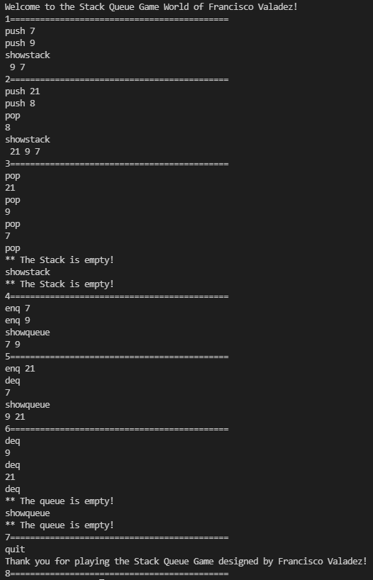

**Test Case 2:**

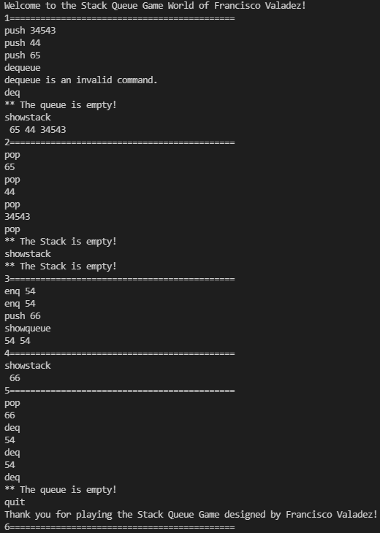

**Test Case 3:**

